Elaborate on the questions you asked, describing what kind of data I needed to answer them,
And where I found it.
Data collection:
I collected Boston crime data from the following URL.
"https://www.moonpage.com/index.html?go=T&auto_dst=T&tzone=et&m=1&d=1&y=1985&hour=0&min=0&sec=0"
Which has crime data of Boston from 2015-06-15 to 2019-01-13.
I downloaded the data in “crime_incident_reports.csv” file and for moon phase data of those years
I used darknight.net api. After getting data I first cleaned the crime data. After cleaning the crime data I merged moon phase data with crime data for further analysis.
For crime data I needed a data where crime incidents will be listed and to see changes due to moon phase change I needed the moon phase data for each day. I collected both from the above source.
I used python library darkskylib library to fetch moon phase data.
Data Cleanup & Exploration
- Describe the exploration and cleanup process
- Imported the crime data using pd.read_csv() of pandas library and stored it in crime data frame.
- Renamed necessary columns.
- Kept only columns needed for my analysis purpose.
- Saw the date range from the date column of crime data frame
- To get idea of the data using head() pandas function saw first five rows
- As date data type was in string converted it to numeric.
- Set date as index
- Counted each crime type by date and reset the index
- Converted the data long to wide format and copied long format to another data frame crimelong
- Used head() to see few rows again
- To get weather data first get a list of unique dates in ‘dates’ variable
- Imported thedarsky library, sorted the dates and fetched data using api into wd data frame
- Stored the weather data into ‘weather.csv’ for future use.
- From weather data kept only date and moon phase data
- Merged crime and moon phase data
- First plotted total number of crimes by crime type
- Calculated average crime over the years and plotted average crime
- Plotted to see the moon phase changes over time
- Saw few rows of total crime and weather data
- Calculated total crime and set total_crime index, saw few rows to get a idea of data
- Plotted yearly total crime
- Plotted average crime by moon phase value
- Finally stored the data in ‘final data.csv’ file.
- Discuss insights you had while exploring the data you didn’t anticipate
Answer: During the analysis I saw 67 types of crime category . Large category of crime and 354796 total crime over was a huge which I didn’t anticipated.I was astonished to see people committed such a large number and various types of crimes. The data types of the variables were not correct which was a problem. I had to correct them. Getting weather data using api took a considerable time and programming. The data had only crime data but for analysis I needed to calculate aggregate value which I didn’t thought earlier.
- Discuss any problems that arose after exploring the data and how you resolved them
Answer: After exploring I found extra not needed data, data in wrong data type, data was in wide format. I resolved them by deleting unnecessary data, converting to appropriate type and reshaping to long format.
- Present and discuss interesting figures during exploration, ideally with the help of Jupyter Notebook
Answer:
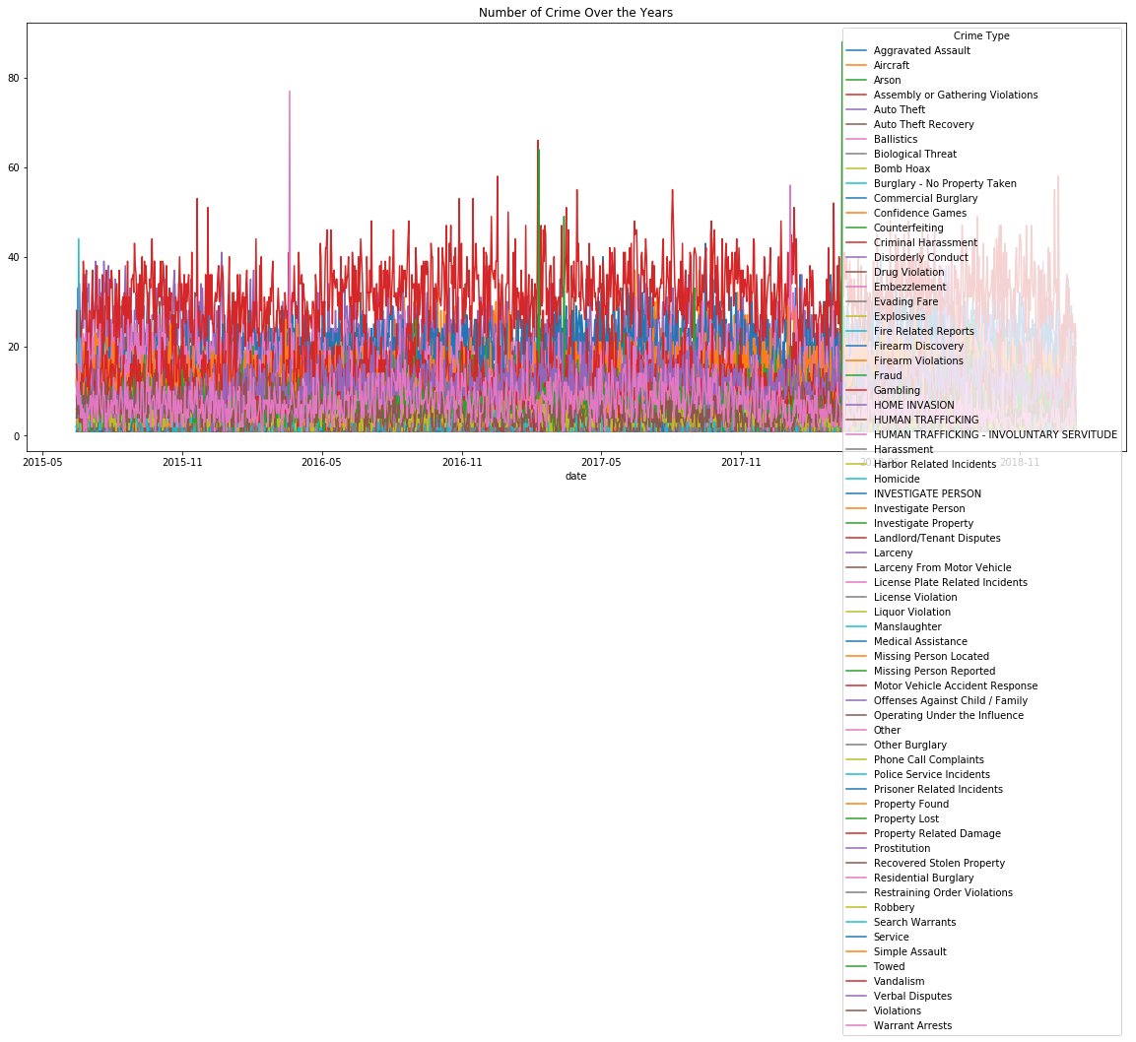
- What information graphs shows?
Answer: The line graph shows each types of total crime over the years. Different colored line indicates different types of crime.
- Why Picked this one?
Answer: Line chart allows to compare values for continuous variables over a long period of time. The total crime is continuous and daily total crime is numerical value. To get a visual comparison thus a line chart is well suited. From the line chart we can see that the number of each types of crime over the years almost remains same but there’s not a significant changes in daily total crime type. There is no trend in different types of daily total crime.
- How does graphs show data collected?
Answer: first calculated total daily crime for each crime type and then plotted on the line chart.
The line graph shows the total daily crime over the year for each crime type. The x axis is date and y axis total crime type, different colored line different crime type.

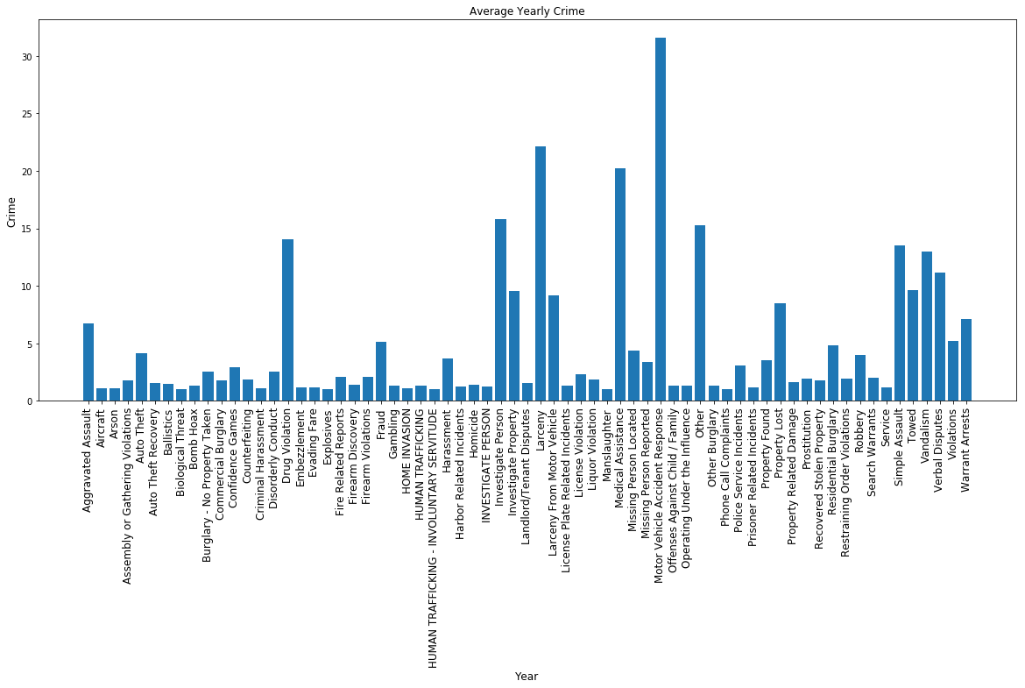

- What information graphs shows?
Answer: The bar graph shows yearly average crime for different types of crime.
2.Why Picked this one?
Answer: Bar chart allows to compare values for categorical variables. The crime type is categorical and average yearly crime of different crime type is numerical value. To get a visual comparison thus a bar chart is well suited. From the bar chart we can see that the higher the bar value the higher the average yearly crime for a specific crime type .
3.How does graphs show data collected?
Answer: first calculated average yearly crime for each crime type and then plotted on the bar chart.
The bar graph shows the data collected by showing yearly average crime during for each crime type. First the average yearly crime were calculated and then plotted. The x axis shows the crime type and y axis bar heights indicates average yearly crime .
.

Average highest crime were Motor Vehicle Accident Response,Vandalism,Other,
Drug Violation,Auto Theft,Aggravated Assault
,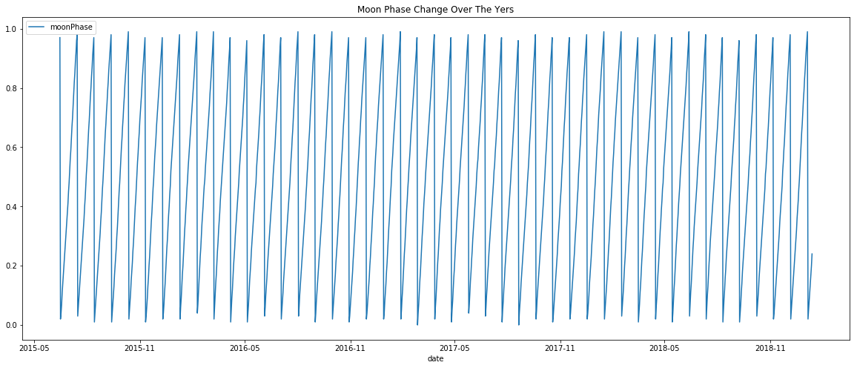
- What information graphs shows?
Answer: The graph shows moon phase illumination value during different time of the year over the total period.
- Why Picked this one?
Answer: I picked this line graph because from it we can see the moon phase i.e. illumination value each day over the total time period. We can see that moon phase at a certain period of time each year increases and decrease at another certain period. The cyclical ups and downs each year moon phase indicates cyclical trend.
- How does graphs show data collected?
Answer: first calculated total daily crime. Then plotted in the line graph.
The graphs shows time on the x axis and moon phase on the y axis. The lines spikes up and downs indicates rise and fall in moon phase illumination value. Here we see a cyclical trend.

Moon cycle changes periodically

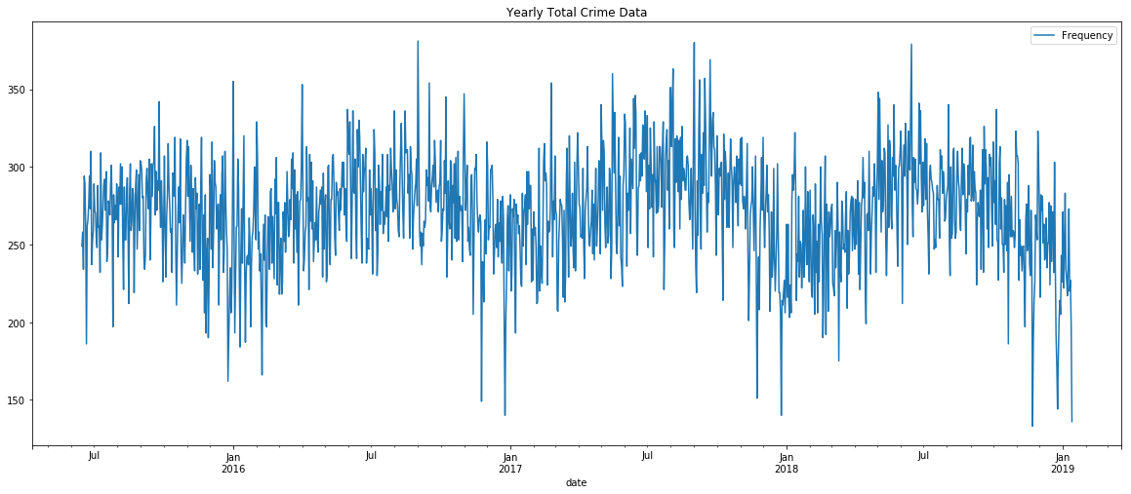
- What information graphs shows?
Answer: The graph shows total crime during different time of the year over the total period.
- Why Picked this one?
Answer: I picked this line graph because from it we can see the total crime each day over the total time period. We can see that total crime at a certain period of time each year increases and decrease at another certain period. So there is effect of time on total crime. The cyclical ups and downs each year total crime indicates cyclical trend.
- How does graphs show data collected?
Answer: first calculated total crime for different moon phase value.The graphs shows time on the x axis and total crime on the y axis. The lines spikes up and downs indicates rise and fall in total crime. Here we see a cyclical trend.

There is cyclical trend in total crime . Total crime increases during July-august and decreases during November, December , January.

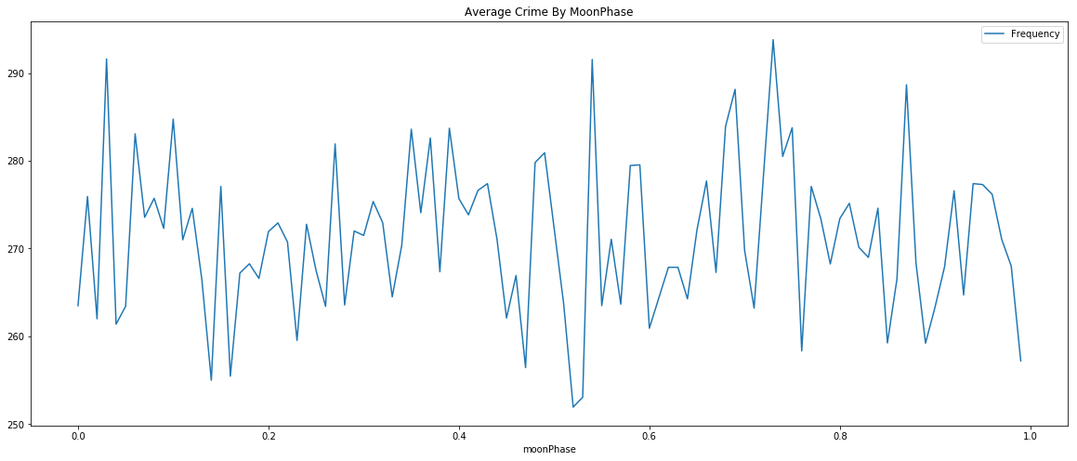
- What information graphs shows?
Answer: The graph shows average crime corresponding to different moon phase illumination value.
- Why Picked this one?
Answer: I picked this line graph because from it we can see the moon phase value on the x axis and average crime on the y axis. We can see that the average value of crime fluctuates with the changing vale of moon phase.
- How does graphs show data collected?
Answer: The graphs shows moon phase on the x axis and average crime on the y axis. The lines spikes up and downs indicates rise and fall in average crime. Here we don’t find any trend. Totally random average crime with respect to moon phase value.

Data Analysis
- Discuss the steps you took to analyze and answer each question you asked in your proposal
Answer:
- I first loaded the data.
- Saw first few rows to get idea about data.
- Calculated correlation to answer question “1. Is there a correlation between moon phase and overall crime rate?” and plotted the correlation
- Saw correlation value to answer “2. Does moon phase correlate to a particular type of crime?” and plotted correlation heat map
- Extracted moon phase data to a separate data frame and took moon phase > 0.98 as full moon.To answer “3. Which types of crimes are committed most during a full moon?”
- Plotted average crime data of full moon phase and sorted descending
- To answer “# 4. Which types of crimes are committed most during a new moon?” Is extracted moon phase equal 0 data. Then plotted the average value, showed the top 10 average crime.

- Present and discuss interesting findings developed during analysis , ideally with the help of Jupyter notebook
Answer:Findings

Is there a correlation between moon phase and overall crime rate?
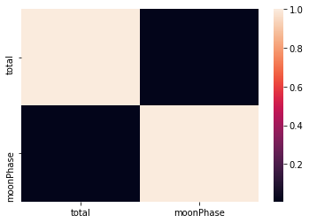

- What information graphs shows?
Answer: The graph shows the Pearson correlation value between moon phase and total crime .
- Why Picked this one?
Answer: I picked this correlation heat map to get a visual representation of the correlation between moon phase and total crime.
- How does graphs show data collected?
Answer: first calculated Pearson correlation value between total crime and moon phase . Then plotted the heat map using sea born library.
The graphs shows the variables on the x and y axis . The intensity of the color indicates Pearson correlation value. The more brighter the color is the more positive value of the correlation and the more darker means less correlation . From the graph we can see that almost dark color of the corresponding cell means the correlation between the variables is very low and negligible.

Yes. There is very low positive correlation between overall crime rate and moon phase. The Pearson correlation value between overall crime rate and moon phase is 0.005254 which is negligible.

Does moon phase correlate to a particular type of crime?
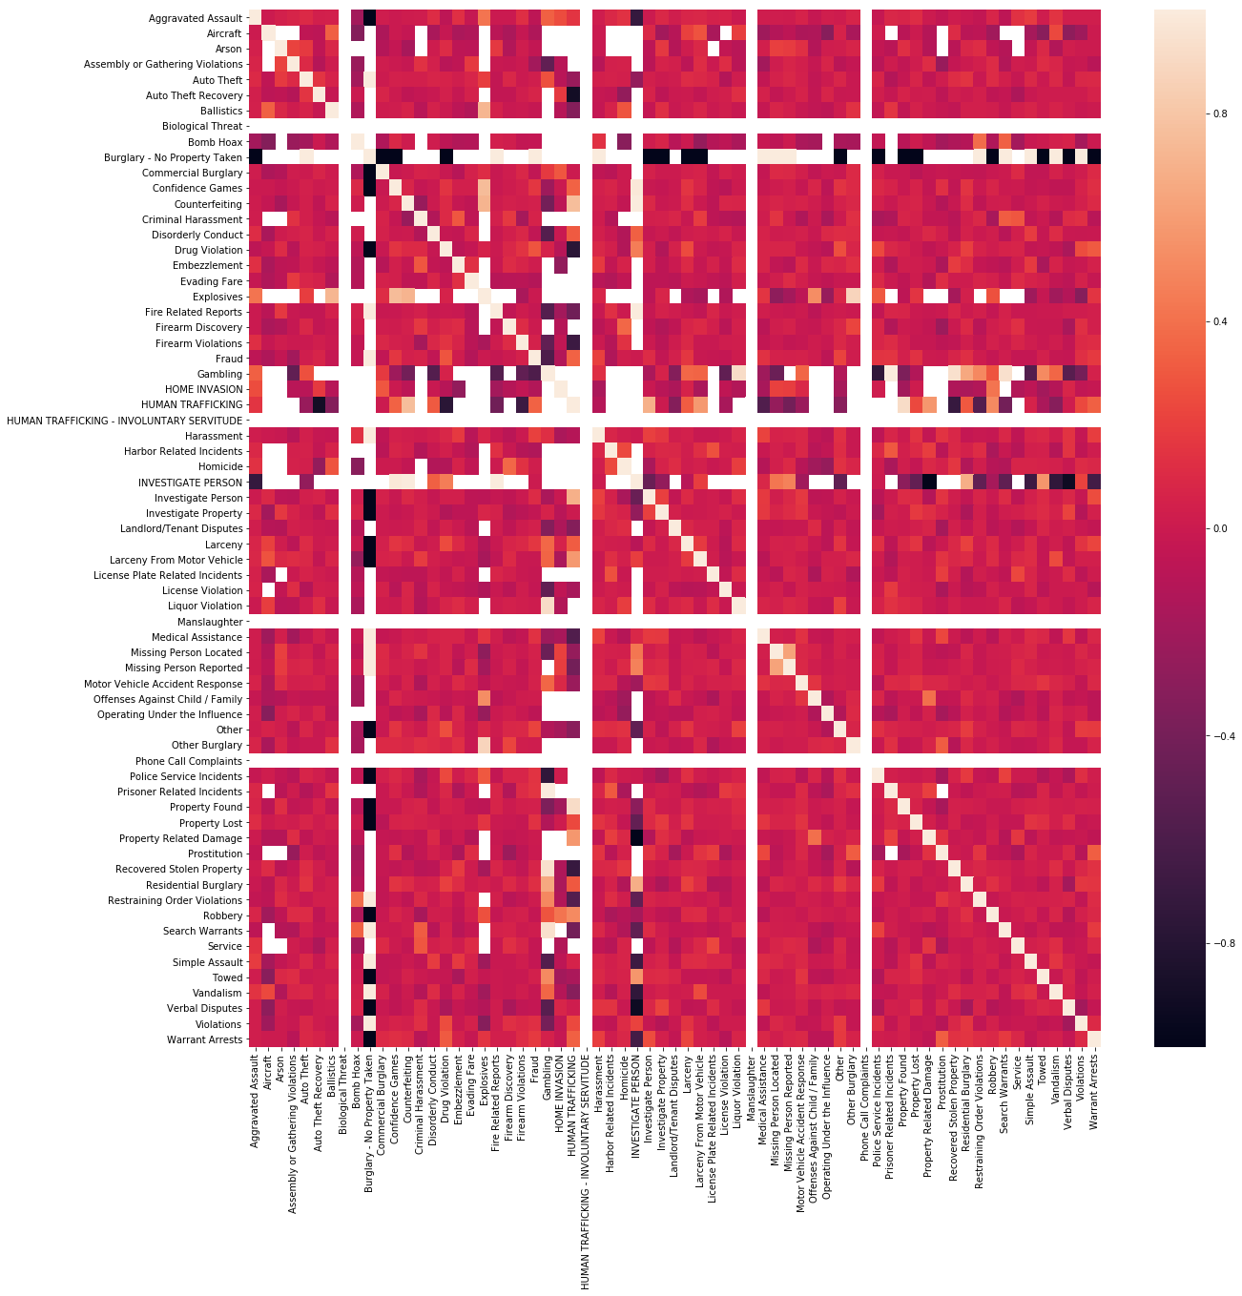
- What information graphs shows?
Answer: The graph shows Pearson correlation between each pair of variable of the moon phase and crime combined data. The color indicates correlation value 1 to -1. The more light the color of corresponding cell of two variables the more positive correlation between them, the more darker color of the corresponding cell of two variables the more negative correlation between them.
- Why Picked this one?
Answer: I picked this one to get a visual idea of the correlation at once of moon phase and other variables. From here seeing the color and intensity I can get a idea of corresponding variables. The reddish colors indicates positive correlation and darker color indicates negative correlation.
- How does graphs show data collected?
Answer: first calculated Pearson correlation value . Then plotted the heat map using sea born library.
The graphs plotted the variables on the x and y axis, their corresponding cell is mapped to a certain color based on the Pearson correlation value between them.

Top 10 crimes correlated with moon phase
Moon phase | Pearson Correlation
HUMAN TRAFFICKING | 0.602498
Homicide | 0.155198
Prostitution | 0.098264
Service | 0.075560
Vandalism | 0.072885
Fire Related Reports | 0.070944
Prisoner Related Incidents | 0.070012
Verbal Disputes | 0.058132
Aircraft | 0.056293

Which types of crimes are committed most during a full moon?
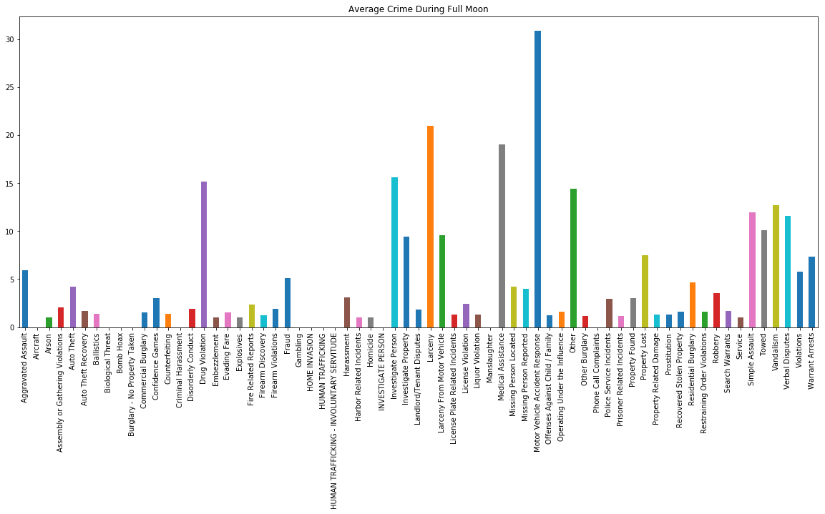
- What information graphs shows?
Answer: The graph is a bar chart. The graph shows average no of crime during full moon for each crime type.
- Why Picked this one?
Answer: Bar chart allows to compare values for categorical variables. The crime type is categorical and average of each crime type is numerical value. To get a visual comparison thus a bar chart is well suited. From the bar chart we can see that the higher the bar the higher the average crime for a specific crime type during full moon.
How does graphs show data collected?
- Answer: first calculated average crime during full moon for each crime type. Then plotted in the bar graph.
The bar graph shows the data collected by showing average crime during full moon for each crime type. First the average crime during full moon for each crime type were calculated and then plotted. The x axis shows the crime type and y axis bar heights indicates average crime value.
Top 10 chimes committed during full moon

 | Average
Motor Vehicle Accident Response | 30.840
Larceny | 21.000
Medical Assistance | 19.000
Investigate Person | 15.600
Drug Violation | 15.120
Other | 14.400
Vandalism | 12.720
Simple Assault | 11.960
Verbal Disputes | 11.600
Towed | 10.125

Which types of crimes are committed most during a new moon?
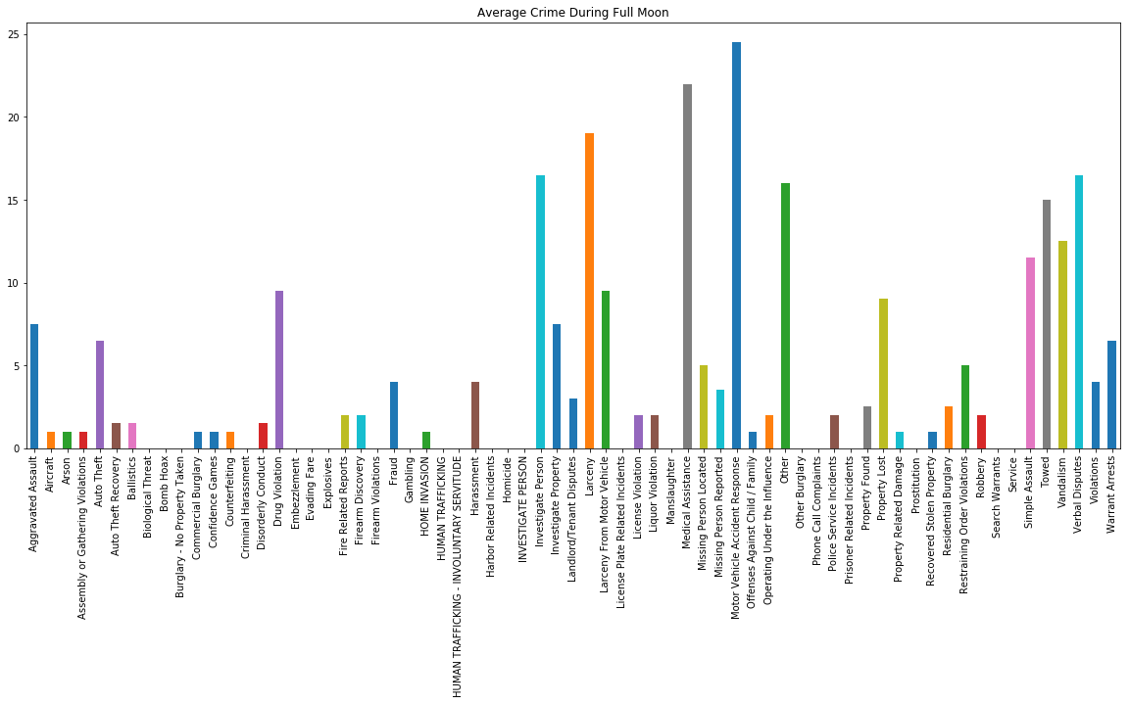
- What information graphs shows?
Answer: The graph is a bar chart. The graph shows average no of crime during new moon for each crime type.
- Why Picked this one?
Answer: Bar chart allows to compare values for categorical variables. The crime type is categorical and average of each crime type is numerical value. To get a visual comparison thus a bar chart is well suited. From the bar chart we can see that the higher the bar the higher the average crime for a specific crime type during new moon.
- How does graphs show data collected?
Answer: first calculated average crime during new moon for each crime type. Then plotted in the bar graph.
The bar graph shows the data collected by showing average crime during new moon for each crime type. First the average crime during new moon for each crime type were calculated and then plotted. The x axis shows the crime type and y axis bar heights indicates average crime value.

Crimes committed during new moon are
 | Average
Motor Vehicle Accident Response | 24.5
Medical Assistance | 22.0
Larceny | 19.0
Verbal Disputes | 16.5
Investigate Person | 16.5
Other | 16.0
Towed | 15.0
Vandalism | 12.5
Simple Assault | 11.5
Drug Violation | 9.5

5 Is there crime difference during Full Moon and new moon?
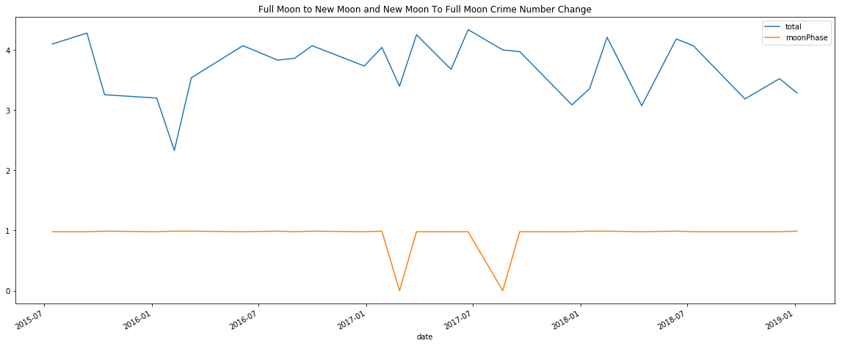
- What information graphs shows?
Answer: The line graph shows total number of crime from full moon to new moon and new moon changes for the years 2015-06-15 to 2019-01-13. The orange color is the moon phase value in percentages of illumination . A value of orange color 1 indicates full moon , value closer to 0 indicates new moon.
- Why Picked this one?
Answer: In order to compare number of crime change from full moon to new moon and new moon to full moon cycle I picked line chart . From the chart I can clearly see and compare crime number ups and down with respect to moon illumination change.
- How does graphs show data collected?
Answer: First separated only full moon and total moon data. Then combined this data and sorted by date. After this we plotted the moon phase illumination and crime data. scaled total crime to fit them together in the line graph.
The graphs shows date on the x axis and on the y axis moon phase value 0 to 1 range in orange color and total crime number by blue color.

Discussion
Discuss your findings . Did you find what you expected to find? If not , why not? What inferences or general conclusion can you draw from your data
Answer: Yes. I’ve found what I expected to find. From the data analysis I can conclude that moon has have effect on crime rate and crime rate changes cyclically during different time of the years.
Post Mortem
Discuss any difficulties that arose, and how you dealt with them
Answer: Difficulties arose during data merge, calculating average values and plotting. I solved them by using Google to find answer , tutorials , reading python documentation and stackoverflow.com answer.
Discuss any additional questions that camp up, but which you didn’t have time to answer. What would you research next, if you had two more weeks?
Answer: Additional questions I came:
- Does geographic area and other weather data impact crime rate?
If I had two more weeks I will explore t his.
Questions
- Open-floor Q&A with the audience

